Big Data Analysis Homework 3: Writing MapReduce Programs

10757025 陳威廷

WordCount.java

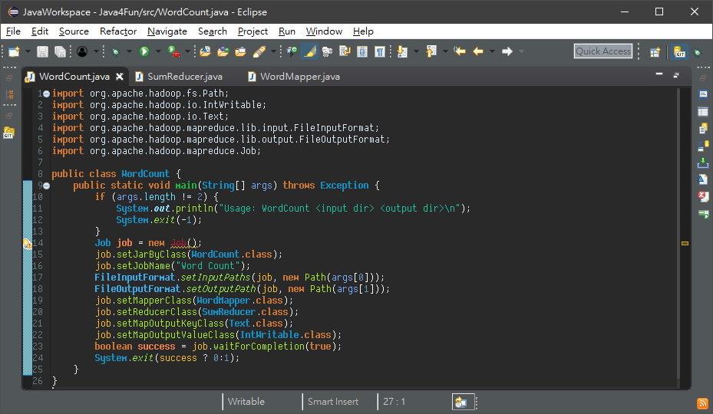

WordMapper.java

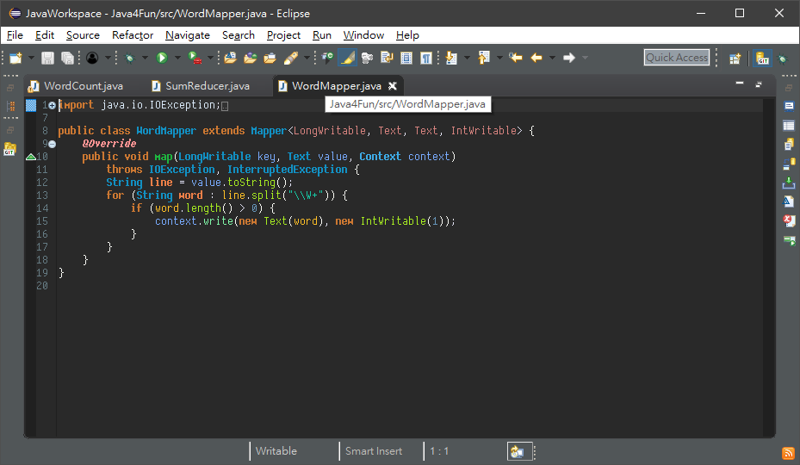

SumReducer.java

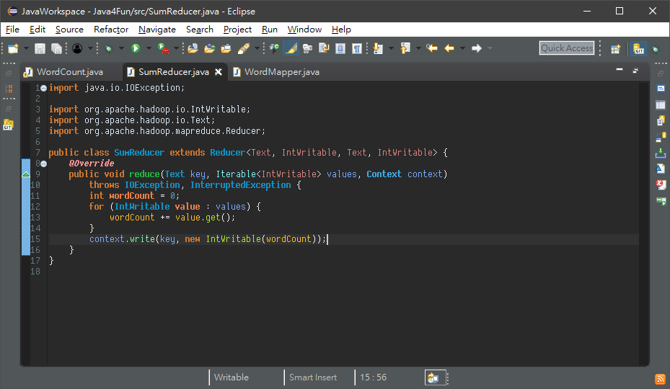

Hadoop Classpath 一直設定失敗，在 ~/.bashrc 加上這幾行才成功

for f in $HADOOP_HOME/share/hadoop/mapreduce/*.jar; do

export HADOOP_CLASSPATH=$HADOOP_CLASSPATH:$f

done

for f in $HADOOP_HOME/share/hadoop/common/*.jar; do

export HADOOP_CLASSPATH=$HADOOP_CLASSPATH:$f

done

for f in $HADOOP_HOME/share/hadoop/hdfs/*.jar; do

export HADOOP_CLASSPATH=$HADOOP_CLASSPATH:$f

done

最後編譯成功的畫面

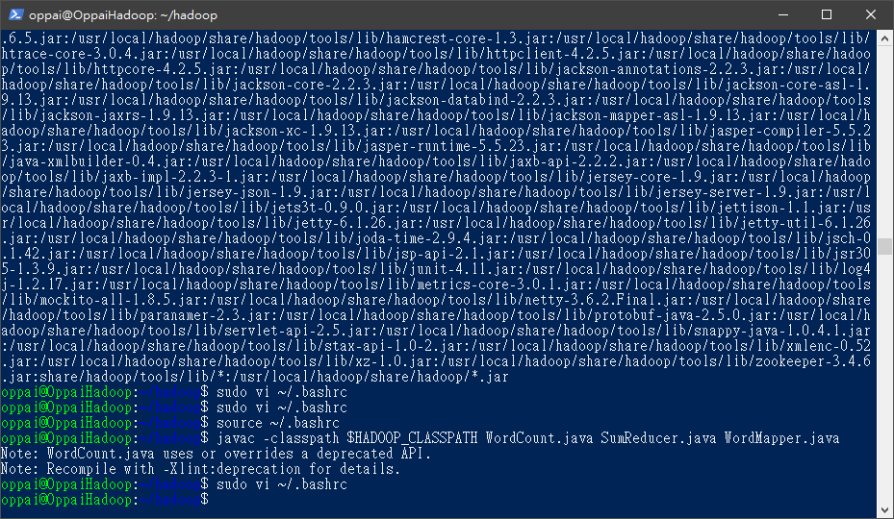

最後成功執行的畫面

